CATARACT CLASSIFICATION

*Y. Pavan Sai*

*Department of AI&ML*

*Vijayawada, Andhra Pradesh, India*

*pavansaiece@gmail.com*

*Abstract:*

This document tells you the researches that are done in order to classify the eyes diseases that are frequently faced by the old-age persons or the senior citizens especially Cataract. We have developed a model for this classification that classifies the disease into two categories either mature or immature. Main aim to develop is to make the work easier just by uploading a picture of eye into the model and obtain the respective results quickly at our doorstep. This is then followed by the methods or the other things that we used in developing this model along with its final accuracy levels and some other data.

**I.INTRODUCTION**

Generally, there are many eye infected diseases and the Cataract is one of the major one which is mainly affected to the old people that damages their eye vision by just forming a white colour precipitate layer around the black eye ball.

How can we identify the disease? How to know its severity level? What kind of classification does the disease is?

So, in order to reduce these circumstances. A model is created that can easily detect the presence of disease and also the type of classification it is, as there were several classes in the Cataract classification like mature and immature.

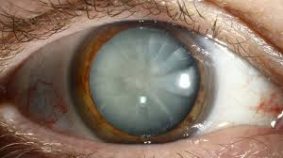

**II.MATERIALS AND METHODS**

We have obtained an image dataset related to the Cataract classification from the Kaggle <https://www.kaggle.com/datasets/akshayramakrishnan28/cataract-classification-dataset>

It mainly consists of approximately 410 images and two classes i.e., mature and immature which are obviously the types of the Cataract disease. All these images are equally distributed into the two classes.

So, coming to the training of model we have taken two main neural networks that are **MobileNetV2** and **ResNet50.** These two networks will then work on our image dataset.

For both we need to change the hyper parameters like epochs as well as the learning rateas below:

1. Keeping the value of **epoch** as 10,20,30
2. Values of **learning rate** varies from 0.01-0.00001
3. **Batch size** can be 16,32,64 according to the dataset

The values of the accuracy must be carefully recorded while performing the process for both the networks.

***MobileNetV2:***

It is a convolutional neural network that is 52 layers deep. You can load a pre-trained version of the network trained on more than a million images from the ImageNet database. The pretrained network can classify images into 1000 object categories, such as keyboard, mouse, pencil and many animals.

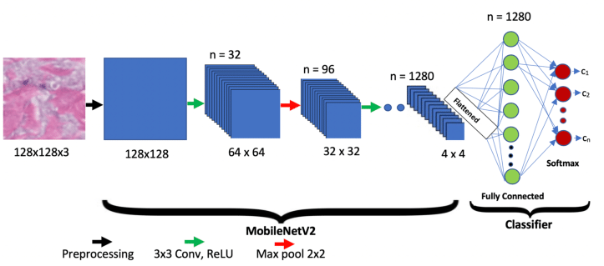

***ResNet50:***

It is a convolutional neural network that excels at image classification. Its like a highly trained image analyst who can dissect a picture, identify objects and scenes within it, and categorise them accordingly.

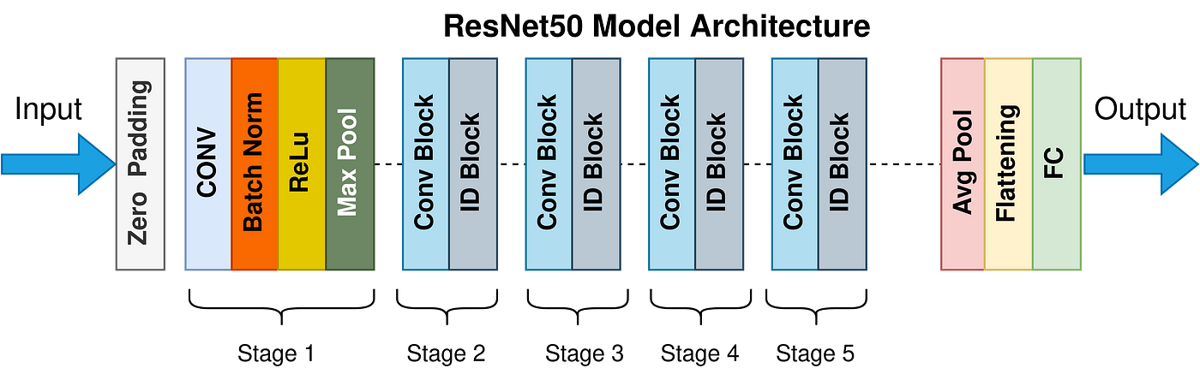

**III.RESULTS**

So, after continuous tuning of the hyper parameters according to the above details for both the networks. The **MobileNetV2** is preferred as the best model depending upon its accuracy level and its consistency as compared to other.

The MobileNetV2 has provided an accuracy of **97.22** whereas the ResNet50 was failed to cross the **80**.

Looking at the confusion matrix provided below you can easily observe that RestNet50 always predicts the same class irrespective of the input which gradually leads to its failure.

You can also see the report of the best model i.e., MobileNetV2.

***ResNet50 report:***

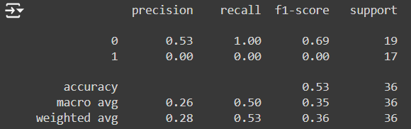

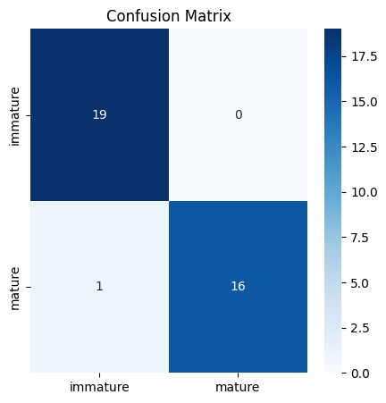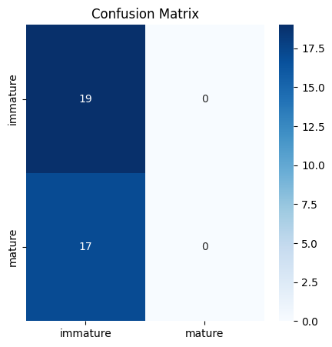

***MobileNetV2 report:***

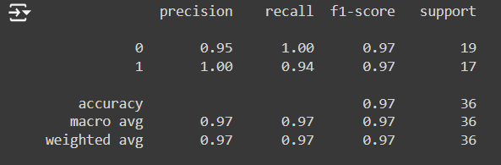

***Graphs:***

From the below graphs we can observe the loss as well as the accuracy of the model that occurred during the training and the validation which are indicated by the red line and the blue line.

We can obtain the train data by the help of splitting i.e., the whole dataset is separated into 80:20 ratio where 80 indicates the train and 20 indicates the test data which plays a crucial role in the development of a model

